Citizen Service Center Management Web System

Senior-2 Project – Completed the requirements for obtaining a bachelor's degree in Software Engineering

Prepared by
George Albert Zaloum

Supervised by
Dr. Akram Massouh

2026 – October

Abstract
Citizen service centers in Syria still complete most recurring administrative transactions, such as civil registry extracts and residence certificates, through paper procedures and repeated in-person visits. This leads to slow processing, paper archives that are hard to search, no way for the citizen to follow a request, and no measurable data with which management can monitor employee performance.
This project aims to design and build a web system that automates the transactions of a citizen service center and gives its management monitoring and control tools. The system serves four roles (Citizen, Employee, Department Manager, System Administrator) in a structure of independent departments with isolated data. The citizen registers with images of the ID card, browses the services, submits requests with their documents, pays the fees and follows the status through a reference number with email notifications. Department Managers build their department's services without programming, while ratings, complaints, an immutable activity log and KPI dashboards support accountability.
The system is developed with Scrum applied in an individual form (Solo Scrum) over five sprints, on a three-tier client-server architecture: React on the client, Django with Django REST Framework on the server and PostgreSQL for the data, with electronic payment through the Stripe gateway in its test mode behind a unified interface. At the time of this report, the requirements analysis, the architecture and the sprint plan are complete, and the first sprint (account and access management) has been specified, designed, and implemented and tested on the server side. The result is a functional prototype; it does not replace integration with government records or a national digital identity.
Keywords: e-government, citizen service center, bureaucratic automation, role-based access control, dynamic service building, key performance indicators

Acknowledgment

I would like to express my sincere gratitude to my supervisor, Dr. Akram Massouh, for the guidance, follow-up and valuable feedback provided throughout the stages of this project. I also thank the faculty members of the Department of Software Engineering at the Faculty of Artificial Intelligence Engineering, Syrian Private University, and the Mukhtar Salim Dawood Azar and the employees of Jaramana Municipality and the One-Stop Window, who shared their experience of the current workflow and made the field study possible.

Dedication

To my family, for their constant support and patience throughout my years of study.

Table of Contents
Abstract ii
Acknowledgment iii
Dedication iv
Table of Contents v
List of Tables vi
List of Figures vii
List of Abbreviations and Symbols viii
Chapter One – Introduction 10
1.1 Project Background 10
1.2 Problem Definition 10
1.3 Project Significance 11
1.4 Project Objectives 11
1.5 Project Scope 12
1.6 Project Contributions 13
1.7 Report Organization 13
Chapter Two – Basic Concepts and Literature Review 16
2.1 Basic Concepts 16
2.2 Literature Review and Previous Work 18
2.3 Comparison of Previous Work 19
2.4 Research Gap 20
References 24
Appendix A 25
Glossary of Terms 26

List of Tables
Table 2.1: Comparison of the studied systems and the proposed system 19

List of Figures
Figure 2.1: Solution block diagram of the proposed system 21
Figure 2.2: Flowchart of the life cycle of a citizen request 22

List of Abbreviations and Symbols

Abbreviation | Full Term | Meaning
API | Application Programming Interface | A defined interface through which the client and the server exchange data.
CSRF | Cross-Site Request Forgery | An attack that makes a signed-in browser send unwanted requests; the system blocks it with a token.
DRF | Django REST Framework | The Django toolkit used to build the system's REST API.
ERD | Entity Relationship Diagram | A diagram of the database entities and the relationships between them.
FR | Functional Requirement | A function the system must provide.
HTTPS | Hypertext Transfer Protocol Secure | The encrypted protocol between the browser and the server.
ID | Identity Document | The personal identity card whose two images the citizen uploads.
JSON | JavaScript Object Notation | The text format of the data exchanged through the API.
KPI | Key Performance Indicator | A quantitative measure of performance, such as the average processing time.
ORM | Object-Relational Mapping | Accessing the database through program objects instead of hand-written SQL.
RBAC | Role-Based Access Control | Granting permissions to users according to their roles.
REST | Representational State Transfer | The architectural style of the system's web API.
SMTP | Simple Mail Transfer Protocol | The protocol used to send the email notifications.
SPA | Single-Page Application | A web interface that runs in the browser and updates without reloading pages.
SQL | Structured Query Language | The query language of the relational database.
UI / UX | User Interface / User Experience | The interface of the system and the quality of using it.
UML | Unified Modeling Language | The standard notation of the system diagrams.

Chapter One

Introduction

Chapter One – Introduction

1.1 Project Background
Citizen service centers are the first point of contact between citizens and the administrative authorities. They handle recurring daily transactions such as civil registry extracts, residence certificates, rental contracts and other official documents, organized in departments such as the Municipality, Traffic and the Civil Registry. Although many of these transactions are simple in content, the current way of completing them relies mostly on paper procedures and in-person visits, which costs both the citizen and the employee considerable time and effort.
The project falls within the field of e-government and the automation of administrative work. It targets the environment of a citizen service center in Syria and relies on the infrastructure available locally, without integration with government bodies.

1.2 Problem Definition
The center completes its transactions through manual, paper-based and face-to-face steps that cannot be traced or measured. The problem can be summarized as follows:
- Slow processing: a transaction passes through several manual stages (receipt, checking, signing, delivery), and the citizen often has to wait in queues or visit the center more than once to complete missing documents.
- Dependence on paper transactions: requests and documents are kept in paper files, which makes them hard to search later, exposes them to damage or loss, and increases printing and storage costs.
- Direct face-to-face contact: requiring physical presence at every stage forces direct dealings between citizen and employee, which may open the door to favoritism or unjustified delay and increases the pressure on front-desk staff.
- Lack of transparency: the citizen usually has no way of knowing the status of a request or the stage it has reached, and the requirements and fees are not published in a uniform and clear way for all transactions.
- Weak monitoring tools: management lacks accurate data on the number of completed requests, their processing time and each employee's performance, so its assessment relies on personal observation rather than measurable indicators.
Affected groups: the citizen, who loses time on repeated visits and cannot follow the request; the employee, who works under the pressure of queues and paper files; and the management of the center and its departments, which cannot measure performance or hold employees accountable with actual data.

1.3 Project Significance
The system moves a large part of these procedures into an organized web environment. The citizen submits the request and documents electronically, follows its status with a reference number and receives notifications when the status changes. The employee processes requests through a unified interface, while management obtains a complete record of operations and performance indicators that support decision-making.
The expected value lies in fewer visits to the center, a traceable path for every transaction, procedures defined and published in a uniform way, and an accountability mechanism based on ratings, complaints and activity logs. The system does not abolish the role of the center or the employee, and does not remove the need for physical presence in transactions that require a signature or the actual collection of a document.

1.4 Project Objectives
The project has the following general objectives:
- Reducing transaction processing time: by allowing requests to be submitted and documents uploaded remotely, and by reducing visits to the center to the necessary minimum.
- Electronic archiving: keeping requests, attached documents and the decisions taken on each request in a central database, which eases retrieval and search and limits dependence on paper archives.
- Standardizing and publishing procedures: defining each service, its requirements and fees in a uniform way inside the system, so that the citizen sees them before applying and all employees handle them by the same criteria.
- Enhancing transparency: enabling the citizen to know the status of a request at any time, and recording every action an employee takes on a request together with its time and performer.
- Providing performance measurement tools: giving management quantitative indicators such as the number of completed requests, average processing time, ratings and complaints, at the level of the center and of each employee.
- Flexible service management: enabling management to add new services or modify the requirements of existing ones through the system interface without changing the source code.
- Raising security and accountability: controlling permissions by job role and department so that no user exceeds the scope of their department, and logging sensitive operations so they can be reviewed when needed.

1.5 Project Scope
The system covers the following areas:
- Account and permission management: citizen registration with the front and back images of the ID card, login and logout, four tiered roles, independent departments with isolated data, and password reset by management.
- Dynamic service building: the Department Manager defines the department's services, their fields, attachments, fees, stamps and completion time without programming; changes do not affect previous requests.
- Request submission and status tracking: a unique reference number, automatic routing to the owning department, controlled statuses (New, In Progress, Awaiting Documents, Completed, Rejected, Cancelled) and email notifications.
- Electronic payment: the Stripe gateway in its test environment behind a unified payment interface, with confirmation through a signed webhook.
- Service rating and complaints: one rating per completed request, and complaints linked to a request and an employee and hidden from the person complained about.
- Performance dashboard, reports and activity log: KPIs at department and center level, employee productivity reports, an immutable activity log and an electronic archive.
The following are outside the scope of the project:
- Integration with the civil registry or any government body, the national digital identity and certified electronic signatures.
- The legal electronic issuance of final official documents.
- Real payment (Stripe is used in its test mode only).
- SMS messages and mobile applications.
- Complex workflows that span several entities.

1.6 Project Contributions
The output of the project is a web system: a React single-page application for the four roles, a Django REST API server and a PostgreSQL database. The expected outcomes are:
- A web system operating with four roles within a structure of independent departments, covering the full transaction cycle from submission to completion.
- A service management module that lets each Department Manager add the department's transactions and modify their requirements without programming.
- A request tracking mechanism by reference number, with automatic email notifications.
- A searchable electronic archive of requests, documents and decisions.
- A performance dashboard and reports at department level and at center level.
- An official channel for ratings and complaints that strengthens accountability.
- An electronic payment module tested through the Stripe gateway in its test environment, and ready by design to be connected to a real payment gateway.
The resulting version is a functionally complete prototype that needs a pilot phase before any actual adoption.

1.7 Report Organization
The project report is organized according to the following structure:
- Chapter One – Introduction: the project background, problem definition, project significance, project objectives, project scope and limits, project contributions and report organization.
- Chapter Two – Basic Concepts and Literature Review:
  - basic concepts, literature review and previous work, comparison of previous work, research gap.
- Chapter Three – Project Methodology and Requirements Analysis: the adopted development methodology, general functional and non-functional system requirements, functional requirements of the current project, feasibility and risks, project plan (Gantt chart, main milestones and task distribution).
- Chapter Four – Analytical and Design Study: high-level architecture diagram (components and data flow), Use Case Diagram (actors and main functions), requirements traceability matrix, Activity Diagram, Sequence Diagram, Class Diagram, Component Diagram, with their responsibilities and relationships, ERD and Sitemap.
- Chapter Five – Implementation: implementation environment, software project structure, module implementation, integration and APIs, updated requirements traceability matrix, deployment and operation.
- Chapter Six – Testing and Evaluation: integration and system testing strategy and plan, test cases and their results, performance evaluation, results analysis, updated requirements traceability matrix.
- Chapter Seven – Conclusion and Future Work: conclusion (summary of what has been achieved and its link to the objectives), limitations encountered, and future work.
- References
- Appendices

Chapter Two

Basic Concepts and Literature Review

Chapter Two – Basic Concepts and Literature Review

2.1 Basic Concepts
This section explains the concepts on which the project is built and which are needed during its analysis, design and implementation.
Bureaucratic automation
Converting recurring administrative procedures with clear rules from manual paper-based steps into steps executed or managed by a computer system [16]. Automation here does not mean removing the human element; it means moving routine tasks (receiving the request, checking that attachments are complete, numbering the transaction and sending notifications) to the system, and leaving decisions that require human judgment to the competent employee.
Citizen self-service
Enabling the citizen to complete part of a transaction personally without an intermediary: reviewing the requirements, filling in the request, uploading documents, paying fees and following the status. This reduces the load on front-desk staff and gives the citizen flexibility in time and place.
Access and permission management (RBAC)
The mechanisms that determine who may access the system and which operations they may perform, in two stages: authentication, which verifies the user's identity, and authorization, which determines the user's permissions. The project adopts the Role-Based Access Control model [11] with four tiered roles (Citizen, Employee, Department Manager, System Administrator) and adds a scope constraint: the permissions of the Employee and the Department Manager are restricted to their own department, while the scope of the System Administrator extends to all departments.
Request life-cycle tracking
Each request is an entity that moves through predefined statuses according to controlled transitions; for example, a request cannot be moved to "Completed" before its requirements are fulfilled. This prevents procedural violations and provides a basis for measuring the time spent in each stage.
Key performance indicators (KPIs)
Quantitative measures used to evaluate the achievement of objectives, such as the average request completion time, the percentage of requests completed within the specified duration and the average citizen rating. In the system they are derived automatically from the data recorded during daily work.
Electronic archiving
Storing documents and data in an organized digital form with metadata (request number, date, service type) that eases search and retrieval, while preserving data integrity and restricting access according to permissions.
Three-tier client-server architecture
The system is divided into three independent tiers [10]: the presentation tier in the user's browser (a React single-page application [7]), the application tier on the server (Django [3]) and the data tier (PostgreSQL [9]). Each tier communicates only with its adjacent tier, so the browser never reaches the database and every permission check is enforced on the server. The application tier is one application divided into internal modules by domain (a modular monolith), not separate microservices.
RESTful web API
The client and the server communicate through resources identified by URLs and manipulated with standard HTTP methods, in a stateless request-response style [4]. The data are exchanged as JSON over HTTPS, and files are uploaded as multipart form data.
Session authentication and web security
After login the server keeps a session and gives the browser an HttpOnly cookie, while a CSRF token protects every state-changing request. Passwords are stored hashed, repeated failed logins lock the account temporarily, and sensitive operations are logged; these measures follow the OWASP guidelines for web application security [8].
Payment gateway abstraction and webhooks
The payment module is placed behind a unified payment interface following the Adapter pattern, so that another gateway can be added later without modifying the rest of the system. The server creates a checkout session with Stripe in its test mode, and the gateway confirms the result to the server with a signed webhook [14].
Agile development with Scrum
Scrum divides the work into fixed time-boxed sprints, each producing a working increment [12]. The project applies it in an individual form (Solo Scrum): the student holds the three roles and the supervisor reviews each sprint's output, while requirements, specifications and UML models are refined sprint by sprint [13].

2.2 Literature Review and Previous Work
This section reviews the current state of practice in delivering citizen services, from the traditional paper-based system to local, regional and global e-government platforms. The paper-based system was studied in the field [2], and the platforms were studied through their public interfaces and documentation; the e-government context is given by the periodic United Nations E-Government Surveys [16].
The traditional paper-based system [2]
The citizen goes in person to the Mukhtar's office with identity documents and presents the request orally. The Mukhtar verifies the identity based on personal knowledge, the paper documents and, when needed, witnesses, then writes, stamps and signs the document. The procedure, if recorded at all, is written in a paper register without uniform numbering.
- Features: Human contextual verification, direct handling of exceptional cases, and no need for digital skills or an Internet connection.
- Limitations: No archiving, slowness and repeated visits, no request tracking or reference number, and no means of measuring the performance or submitting a complaint.
The Syrian Electronic Citizen Service Center – ecsc.gov.sy [15]
The citizen creates an account and selects the transaction from a predefined list. High-demand transactions, such as civil registry documents, are automated through electronic forms with a fixed structure, and fees are paid through local payment gateways. The transaction ends with electronic delivery or collection from a center.
- Features: Removes paper forms from automated transactions, reduces congestion, and proves the feasibility of local electronic payment.
- Limitations: A static system: management cannot add a transaction or modify its requirements from an administrative interface; the citizen cannot rate the processing employee or file a complaint linked to the transaction; and there are no KPI dashboards on employee activity and delayed requests.
TAMM platform – Abu Dhabi, UAE [1]
A comprehensive government platform that brings the services of Abu Dhabi's government entities into a unified application and portal. It retrieves the user's data proactively from official sources, and verifies identity through the national digital identity (UAE PASS).
- Features: An excellent user experience with few steps and fields, and services classified around the user's needs and life stages.
- Limitations: It depends on complex integration with the databases of state entities and on a national digital identity, which cannot be applied in this project; the project replaces it with simplified verification by ID card images and the phone number.
GOV.UK – United Kingdom [5], [6]
Interfaces built on absolute simplicity following a unified design system, and step-by-step guidance following the "one thing per page" pattern with a final review page before submission.
- Features: Simple electronic forms split into short steps with clear error messages, which lowers the rate of errors and incomplete requests.
- Limitations: An exclusive focus on the citizen's interface: internal monitoring and staff management are left to the back-office systems of each entity.

2.3 Comparison of Previous Work
Table 2.1 compares the studied systems with the proposed system on two of the criteria that the project targets.
Table 2.1: Comparison of the studied systems and the proposed system
Study | Technologies Used | Feature 1: Dynamic Service Building | Feature 2: Employee Rating and Complaints | Strengths
Traditional paper-based system [2] | Paper forms, manual registers, stamps and signatures | Requirements set by custom and orally at the Mukhtar's discretion | No official channel; objections are made orally or escalated outside any record | Human verification and direct handling of exceptional cases
Syrian Electronic Citizen Service Center [15] | Web portal, fixed electronic forms, local payment gateways | A fixed list of transactions; changes require development work | The citizen cannot rate the processing employee or file a linked complaint | Less paperwork and congestion; feasible local electronic payment
TAMM platform, UAE [1] | Unified app and portal, proactive data integration, UAE PASS digital identity | Services added by central development teams and integration with the owning entities | Satisfaction measured for the service, not for a specific employee | Excellent user experience and needs-based service classification
GOV.UK, UK [5], [6] | GOV.UK Design System, GOV.UK Pay, central identity verification | Each entity builds its service with its own technical team | Satisfaction surveys on the digital service, not linked to an employee | Simple step-by-step forms with clear error messages
Proposed system | React, Django REST Framework, PostgreSQL, Stripe (Test Mode), SMTP | Department Managers define fields, attachments, fees and stamps without code; simple transactions only | Rating after completion linked to the employee; complaint routed to the manager and hidden from the employee | Strict role and department separation, activity log and KPI dashboards

The cells are descriptive: the proposed system targets a single service center with limited resources, and these features do not mean that it outperforms integrated, well-funded government platforms such as TAMM or GOV.UK.

2.4 Research Gap
Through the analysis of the previous studies, the following gaps that this project seeks to address can be identified:
- Static services: in the local portal, adding a transaction or changing its requirements needs development work. The project provides a service builder with which each Department Manager defines the department's transactions without code.
- No citizen oversight of the employee: none of the studied systems links a rating or a complaint to the employee who processed the request. The project adds a rating after completion and a complaint routed to the employee's manager and hidden from the person complained about.
- No measurement of internal performance: the public platforms do not expose KPIs on employee activity and delayed requests. The project builds a KPI dashboard and an immutable activity log at department and center level.
- Integration-dependent verification: advanced platforms rely on government integration and a national digital identity that are not available locally. The project uses simplified verification by ID card images, with strict separation of permissions and department data isolation.
- Citizen-only focus: global portals simplify the citizen's interface but leave back-office processing to each entity. The project treats the employee's processing and the management's control as a core part of the system.
Proposed solution idea
The proposed solution is a web system for a single citizen service center that combines what is applicable within the local infrastructure with the proven practices of the studied platforms: simplified verification instead of government integration, step-by-step forms with the requirements shown before submission, and a payment module behind a unified interface. Figure 2.1 shows the solution as blocks: the inputs of the four roles, the eighteen functional modules of the system grouped by area, the outputs to each role, and the supporting components.
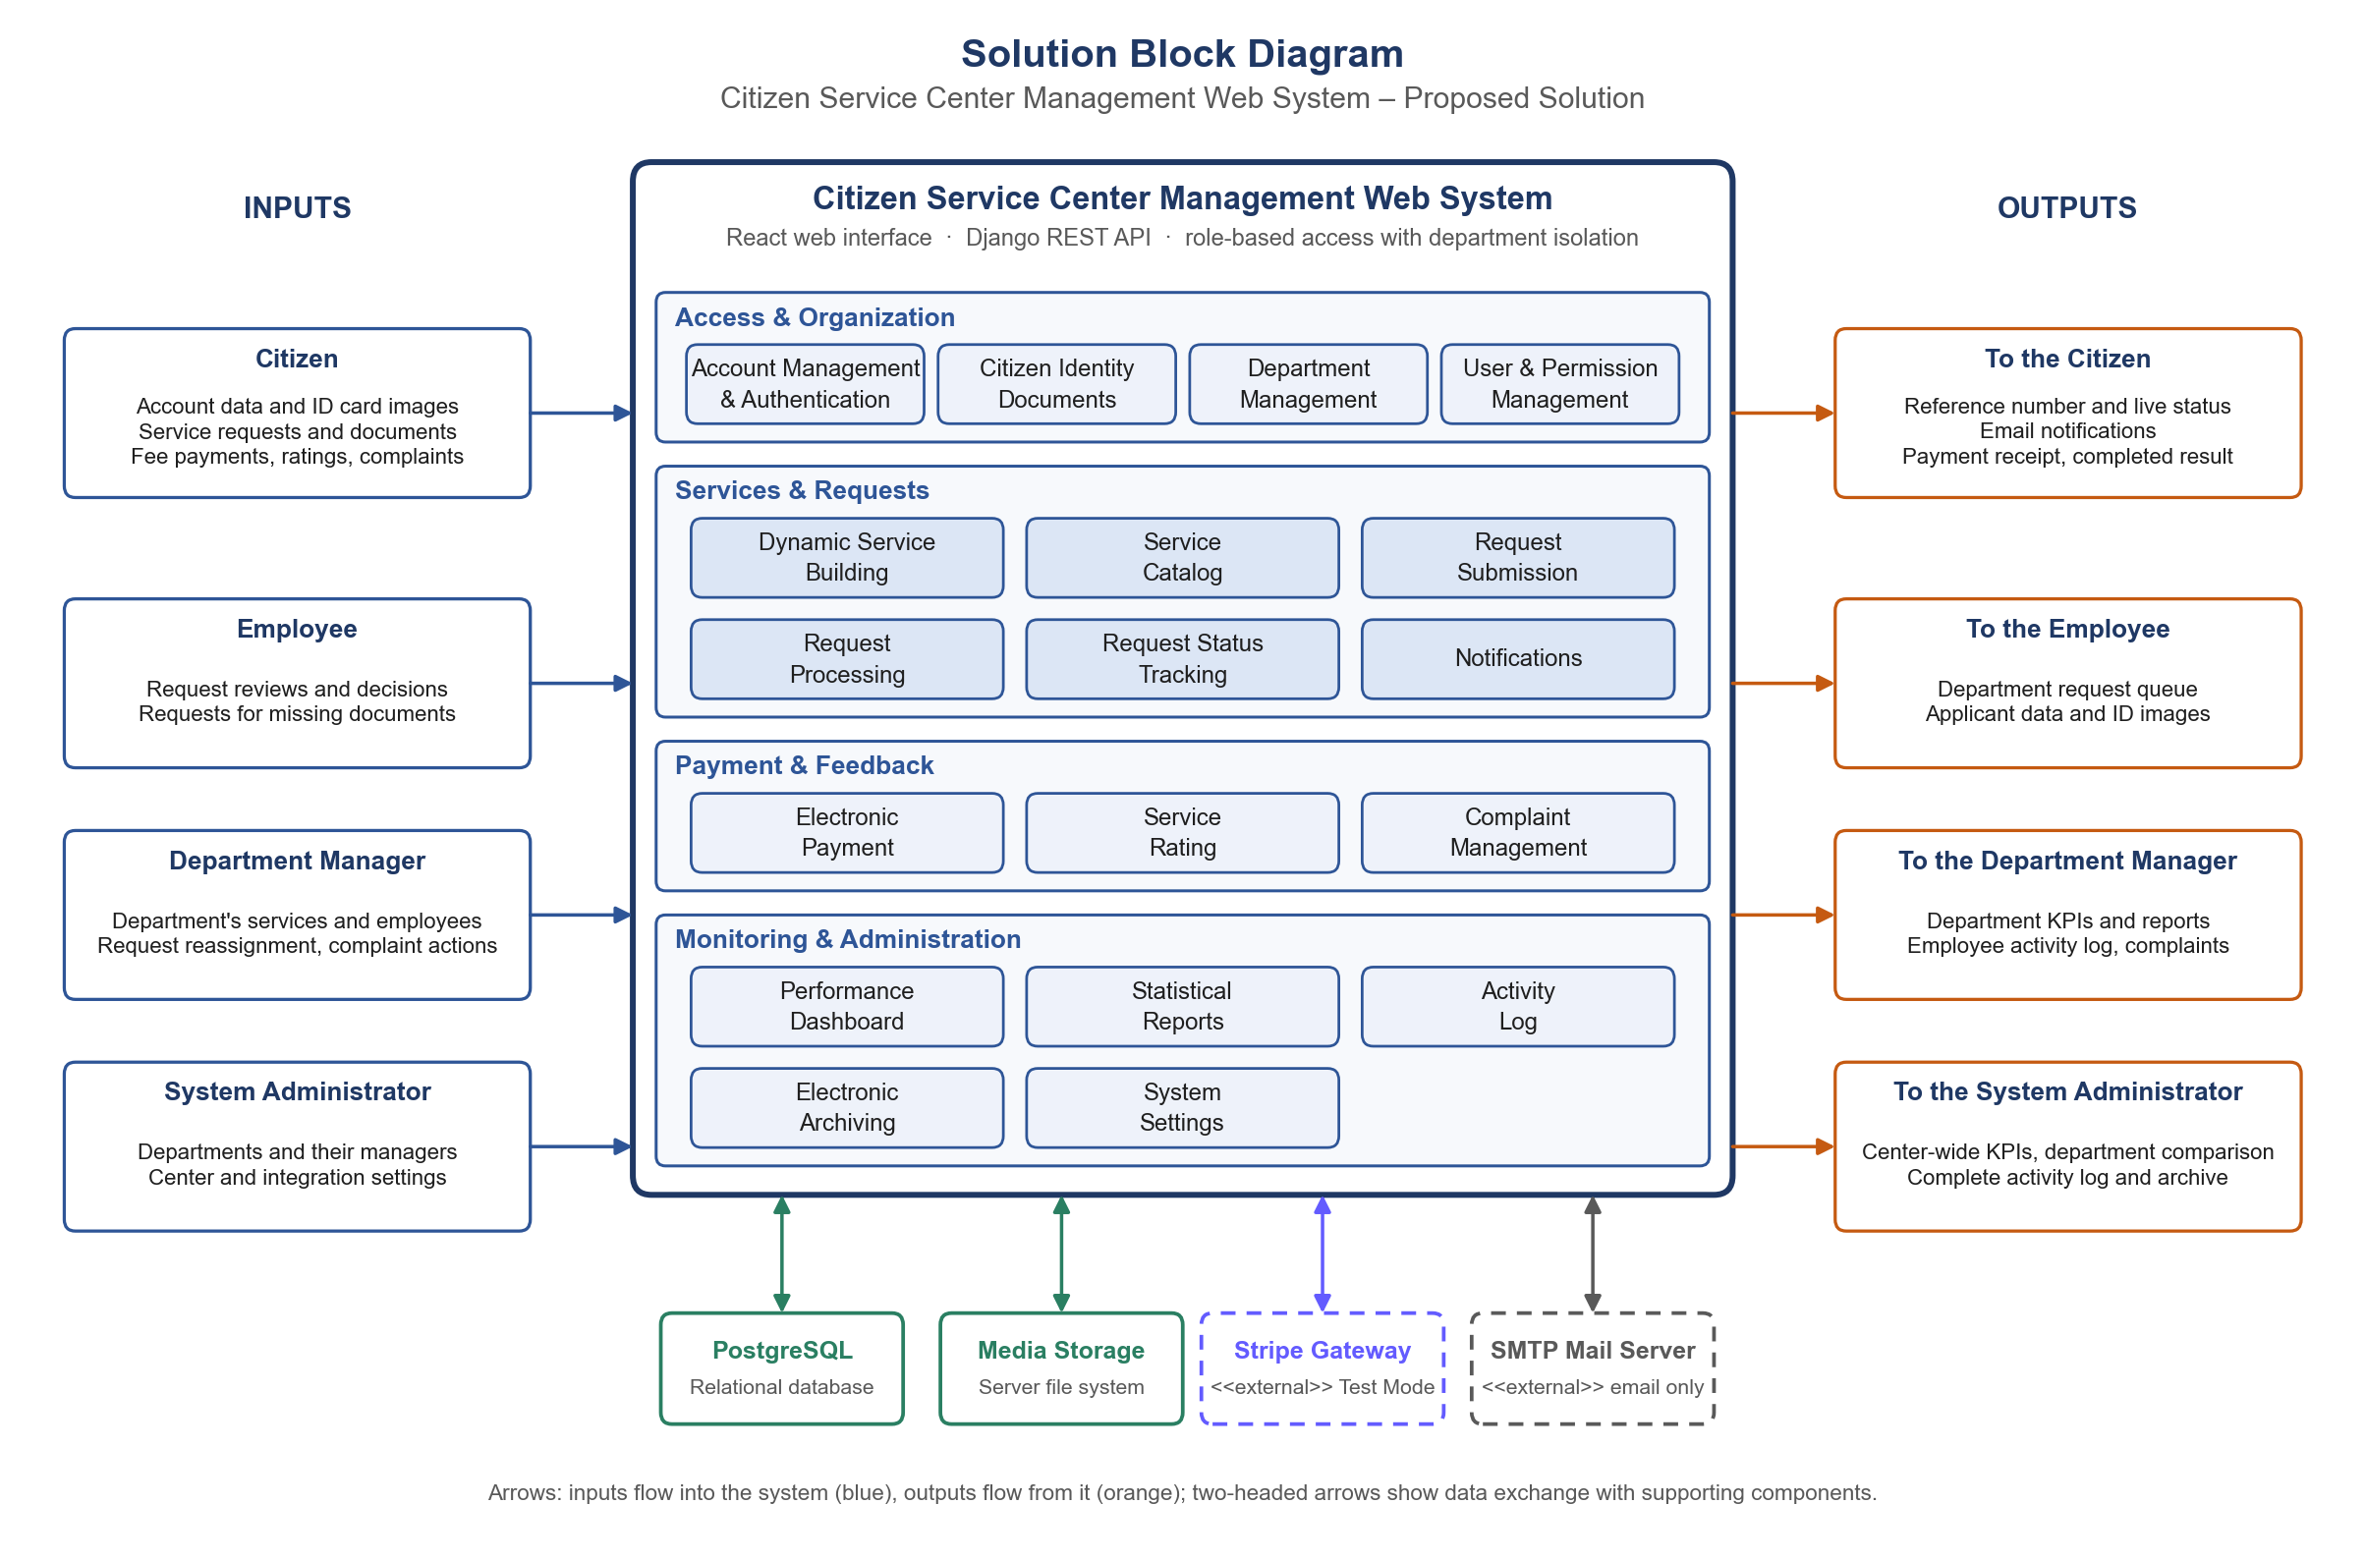
Figure 2.1: Solution block diagram of the proposed system
Key of Figure 2.1: blue boxes and arrows are inputs into the system, orange boxes and arrows are outputs from it; shaded blocks are the request life-cycle modules; solid green boxes are internal data components and dashed boxes are external services (Stripe in its test mode and the SMTP mail server).
Figure 2.2 shows the flow of a request from the citizen's registration to the archiving of the closed request, including payment for paid services, the request for missing documents and the rejection path.
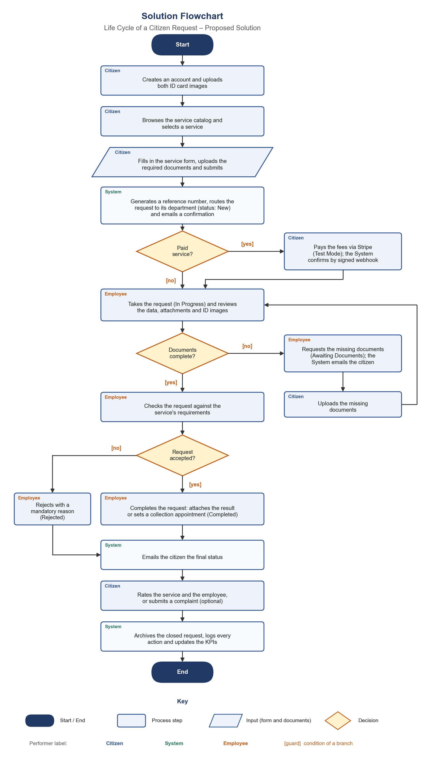
Figure 2.2: Flowchart of the life cycle of a citizen request
Key of Figure 2.2: rounded navy boxes mark the start and the end, rectangles are process steps, the parallelogram is an input, diamonds are decisions with their conditions in orange brackets, and the label at the top of each step names its performer (Citizen, System or Employee).

References
- Abu Dhabi Digital Authority, "TAMM – Abu Dhabi Government Services." [Online]. Available: https://www.tamm.abudhabi
- S. D. Azar, Mukhtar of Karm Hadid Neighborhood, and employees of Jaramana Municipality and the One-Stop Window, private communication (field study), 2026.
- Django Software Foundation, "Django Documentation." [Online]. Available: https://docs.djangoproject.com
- R. T. Fielding, "Architectural Styles and the Design of Network-based Software Architectures," Ph.D. dissertation, Univ. of California, Irvine, CA, USA, 2000.
- Government Digital Service, "GOV.UK – The best place to find government services and information." [Online]. Available: https://www.gov.uk
- Government Digital Service, "GOV.UK Design System." [Online]. Available: https://design-system.service.gov.uk
- Meta Open Source, "React Documentation." [Online]. Available: https://react.dev
- OWASP Foundation, "OWASP Top 10:2021." [Online]. Available: https://owasp.org/Top10/
- PostgreSQL Global Development Group, "PostgreSQL Documentation." [Online]. Available: https://www.postgresql.org/docs/
- R. S. Pressman and B. R. Maxim, Software Engineering: A Practitioner's Approach, 9th ed. New York, NY, USA: McGraw-Hill, 2020.
- R. Sandhu, D. Ferraiolo, and R. Kuhn, "The NIST model for role-based access control: Towards a unified standard," in Proc. 5th ACM Workshop on Role-Based Access Control, Berlin, Germany, 2000, pp. 47–63.
- K. Schwaber and J. Sutherland, The Scrum Guide, 2020. [Online]. Available: https://scrumguides.org
- I. Sommerville, Software Engineering, 10th ed. Boston, MA, USA: Pearson, 2016.
- Stripe, "Testing – Stripe Documentation." [Online]. Available: https://docs.stripe.com/testing
- Syrian Electronic Citizen Service Center, "ecsc.gov.sy." [Online]. Available: https://ecsc.gov.sy
- United Nations Department of Economic and Social Affairs, United Nations E-Government Survey 2024, New York, NY, USA: United Nations, 2024.

Appendix A

Glossary of Terms

Term | Arabic Translation
Activity Log | سجل النشاط
Citizen Service Center | مركز خدمات المواطنين
Complaint | شكوى
Department | قسم
Department Data Isolation | عزل بيانات الأقسام
Department Manager | مدير القسم
Electronic Archiving | الأرشفة الإلكترونية
Employee | موظف
Increment | الإصدار التراكمي
Key Performance Indicator | مؤشر الأداء الرئيسي
Mukhtar | المختار
Payment Gateway | بوابة الدفع
Rating | تقييم
Reference Number | الرقم المرجعي
Request | طلب
Self-Service | الخدمة الذاتية
Service (Transaction) | خدمة (معاملة)
Sprint | دورة تطوير (سبرنت)
System Administrator | مدير النظام

